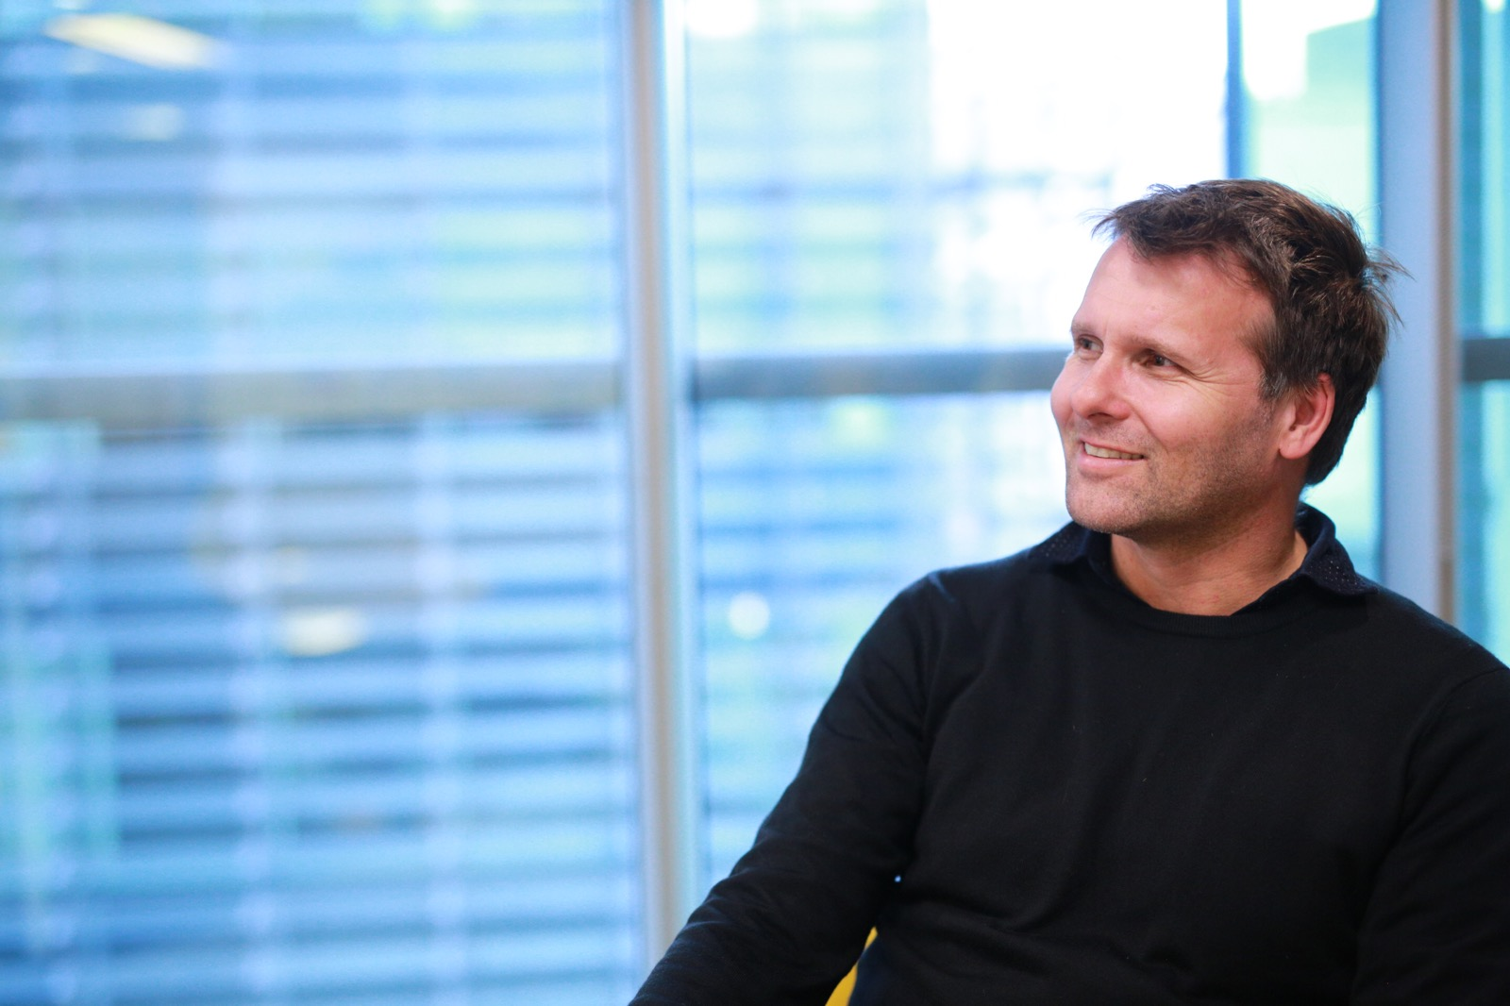

Mike Campbell, Head of International Effectiveness
Ebiquity

Mike leads Ebiquity’s International Effectiveness Group, which undertakes multi-territory modelling, testing and consultancy to help brands optimise their ROI across markets. Prior to joining, Mike spent 12 years at Ninah Consulting as Managing Director of its London office and Global Head of its FMCG Centre of Excellence, working with companies such as Nestlé, Diageo and General Mills.

Prior to Ninah, Mike commercially headed up IRI’s modelling practice in Europe.

